**Modeling and Simulation of water towers in a day ahead market environment**

Water towers are an essential part of the basic infrastructure of urban and rural areas. These tall structures ensure the availability of clean drinking water and allow the pressure in the network to be controlled. Nowadays, with the move towards renewable energies, the use of solar energy is also playing an increasingly important role. This task focuses on how to optimize the water pumping of water towers in response to variations in solar energy production. Indeed, the price of solar energy varies with the weather and between sunny periods and night time. Our aim is to develop a method that ensures adequate water supply for water towers while minimizing the costs associated with the use of solar energy. This research is planned to investigate optimal operation options during its planned phases, focusing on sustainable management of water resources, emphasizing the importance of energy saving and environmental sustainability.

Water towers are hydroelectric equipment whose main components are an electric pump and an enclosed reservoir. The electric pump can be switched on and off. When on, it consumes electricity. Our aim is to find a binary set that can operate the pump in a cost-efficient way, and it is important that there is always enough water in the closed reservoir to meet the needs of the settlement.

**Water Towers**

Water towers are used as a local source of water at times of peak demand where it would not be economical to increase the size of the supply pipeline and add a booster pump[3] installation. In undulating terrain, ground level storage could provide the pressure needed, but in areas of flat topography the storage must be elevated. Many shapes and design features are possible, but the designer should aim to produce a structure that meets the requirements of the water supply and planning authorities, bearing in mind that it will become a landmark in the community which it serves. Ancillary equipment[4] including pipework, valves, ladders, instrumentation and booster pumps, if required, can all be hidden in the cylindrical shaft.

The optimum depth/diameter ratios should be determined taking into account the most efficient shape and the needs of the distribution system. It is usually advisable to avoid large pressure fluctuations in distribution that may be caused by drawdown or filling in excessively deep tanks.

**Data Collection**

The highest impacts were observed for the case of electricity consumption. In fact, a growth of 20% in the attitudes for pro-environmental behavior of final electricity consumption reduced this consumption with respect to the BAU scenario by 1%. The opposite, i.e., a decline of 20% in pro-environmental behavior, impacted final electricity consumption with an increase of approximately 1%. In the case of gas consumption, the observed variation with respect to the BAU scenario was 0.6%, while in the case of water consumption, it was 0.2%. The results indicate that pro-environmental attitudes impact electricity consumption more than gas and water consumption.  
The same variations were not observed in the case of market cost variations. In fact, the changes in attitudes within the same range produced impacts that were within 0.2% for electricity, gas and water. Thus, the results of the sensitivity tests indicate the relevance of collecting accurate data on pro-environmental attitudes, which have a higher impact on the reliability of the final results.  
Another aspect, in addition to the relevance of the data collection phase, which was proved by the sensitivity analysis, is the application of simulations to support policy-making. The relevance of simulation and visualization tools in urban environmental planning is already acknowledged in the literature. Considering the rapid growth of cities and considering the environmental, social and economic impacts of such a phenomenon, the quality of life of citizens may be at risk. The opportunity for rapid data collection, which is supported by the existing and developing information and communication infrastructures, may help urban planners to improve the quality of the modeled scenarios for the future of cities.  
Our plan is to find and collect large amounts of data based on the water consumption in settlements, where water towers are being used as the primary water source. Also we will collect data on the price fluctuation of solar energy. If we can gather enough data in respect to water consumption and energy prices we will create a machine learning model to predict future fluctuations. Collecting data and being able to predict future energy prices and water consumption will enable us to create optimal policies to control the water towers pumping.

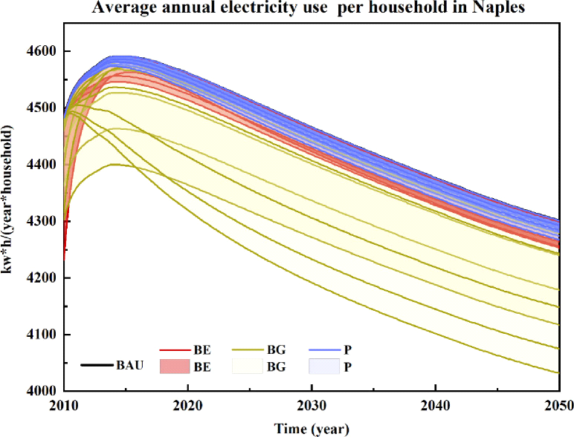

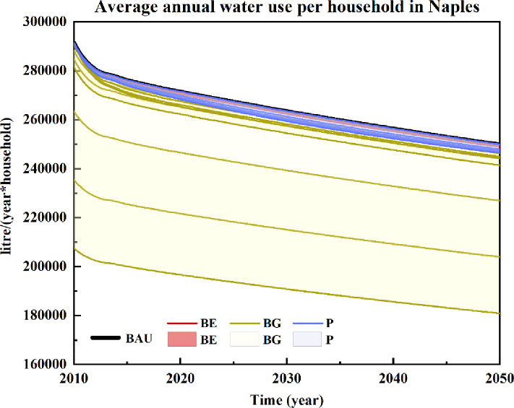

**Model Development**

Water towers are large, elevated tanks of water that are essential for the distribution of clean water to many communities across the globe. Not only do they come in many different shapes and sizes, but it’s intriguing to learn about the way water towers work. Whether you need a model water tower for a train set or school project, or you simply want to learn about the way they work, you can easily build your own model with the right materials and know-how.  
Our goal is to develop a simulation of a water tower using the MATLAB or the Simulink programing language. Simulating the water tower will help us understand the underlying physics and lets us to create a mathematical model which we can use to solve the initial problem of cost/power-efficient control of the tower.

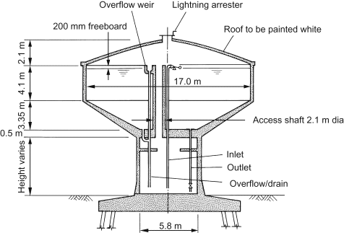

|  |  |  |
| --- | --- | --- |
| **Size (m3)** | **Depth of water (m)** | **Internal diameter (m)** |
| **1200** | **7.5** | **17.0** |
| **2000** | **9.1** | **19.4** |
| **3000** | **10.2** | **22.6** |

**Optimization**

Optimization, in its essence, is the art and science of refining processes, systems, and resources to achieve the highest level of efficiency, productivity, and excellence. It is a fundamental concept that permeates various fields, from engineering and economics to biology and computer science. There are many optimization algorithms to consider. There are traditional algorithms like Newton - Gauss, Gradient descent, Levenberg-Marquardt. Also there are machine learning algorithms, like Deep Neural networks. These algorithms can work differently on different problems so finding a good algorithm for our specific purpose is important.

**Analysis of Results**

The electricity production from intermittent renewable energy sources, such as wind and solar power, has increased significantly, which requires the electricity grid to be gradually restructured through different approaches. Demand Response (DR) is one of the examples which is applicable to a broad variety of electricity consumers, from households to sizable industrial processes. However, there is a barrier to implementing DR in that consumers may not be willing to change their behavior or invest in energy management technologies without gaining enough monetary benefits from doing so. The purpose of this study is to investigate the behavior of electricity consumers who are offered implicit DR solutions and to investigate which parameters characterize the consumers who adopt these solutions. The study applies an agent-based simulation model that uses separate and independent modules for the domain logic, the business solution logic and the DR adoption decision logic, respectively. The simulation results show that tower/pump pairs on water distribution systems with higher water demands adopt the implicit DR solution faster. The pumping rate and tank capacities do not have a significant impact on the adoption, at least not if they are beyond a certain size.

**References**

1. datasciencecampus.ons.gov.uk

2. ansonindustry.com

3. https://www.sciencedirect.com/topics/engineering/booster-pump

4. https://www.sciencedirect.com/topics/engineering/ancillary-equipment